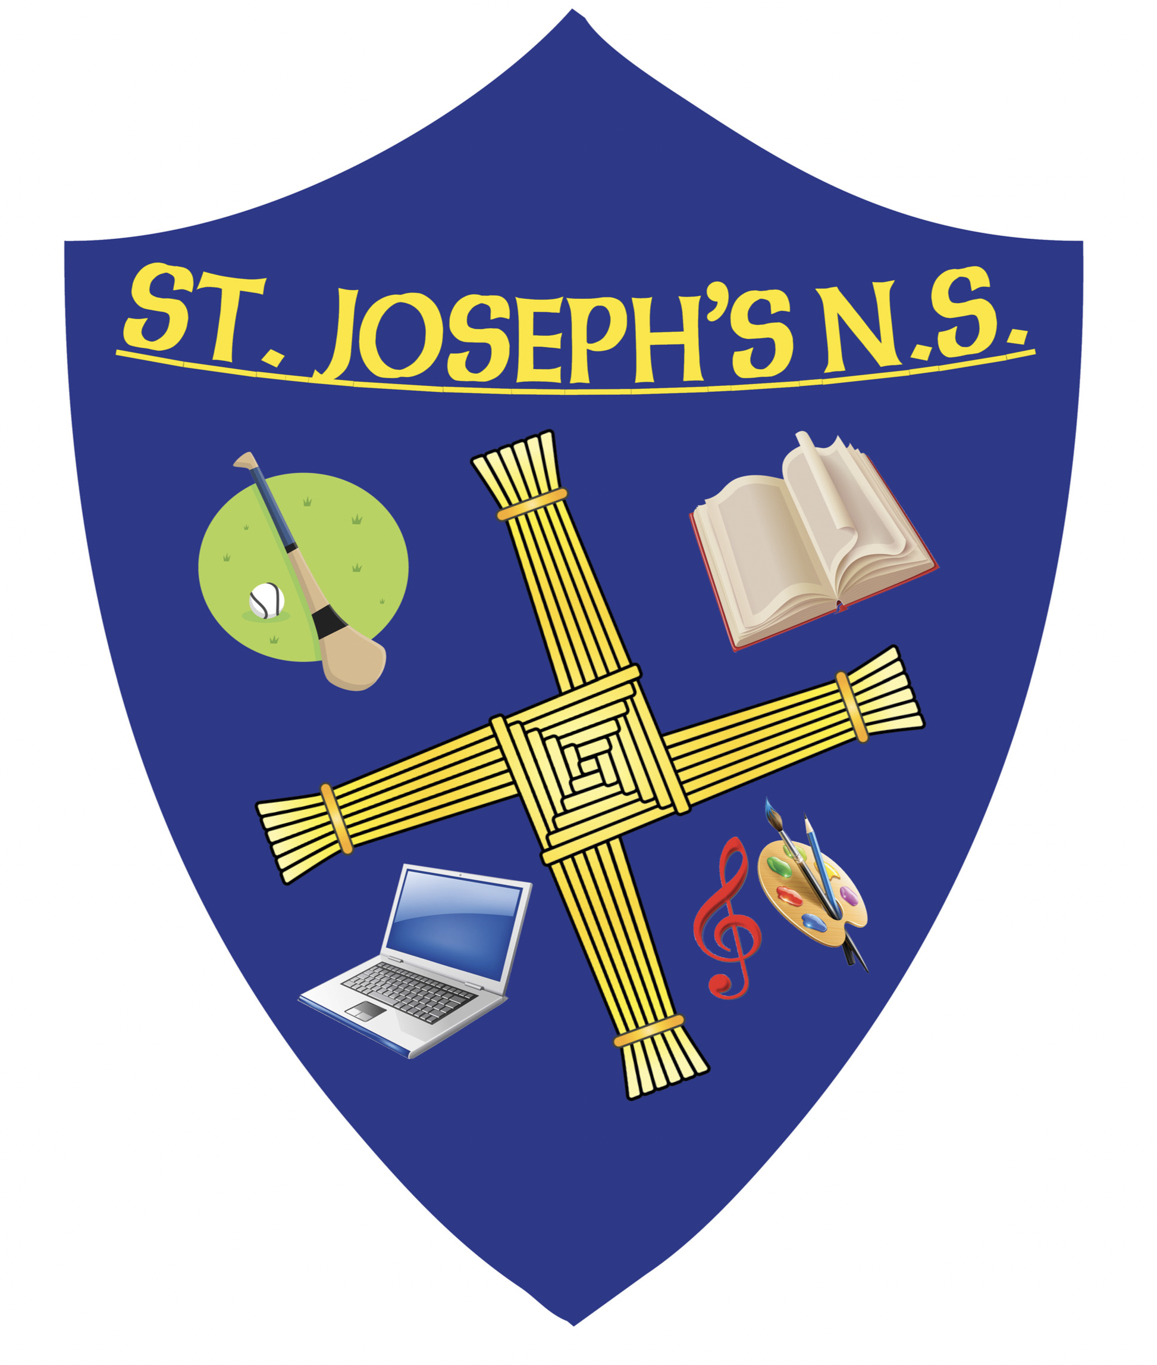
School Prospectus 2024
St. Joseph’s NS
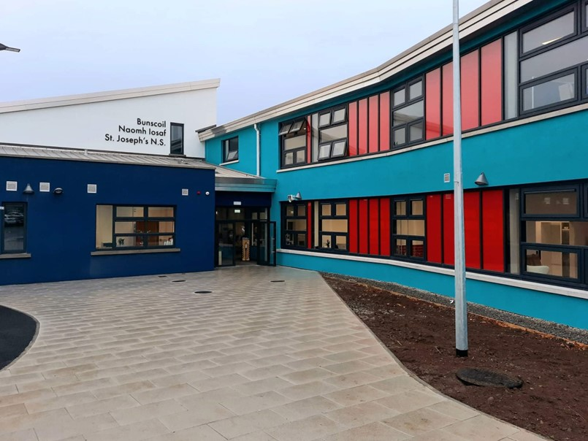

www.stjosephskilcock.com Tel: 01-6287 628
e-mail: office@stjosephskilcock.com

Success for all, a happy school
Learning and growing Together
WELCOME TO ST. JOSEPH’S NS
KILCOCK

Fáilte is céad go Scoil Naomh Iosaif. Welcome to St Joseph’s NS.
St. Josephs NS is a co-educational, vertical primary school under the Patronage of the Catholic Bishop of Kildare and Leighlin – Bishop Denis Nulty. Our ethos is Catholic and we are fully inclusive of all, regardless of background, religion or ability. It is in this atmosphere that the spiritual, moral, intellectual, social and physical growth of our students is nurtured.

St. Joseph’s NS originally began in School Street, Kilcock in 1872 when the Christian Brothers built the school from stone left over from the construction of the local church tower. It cost a total of £1,800 – how times have changed? Our present building opened on the Feast of Saint Joseph, 19 March 1980 as a Boys’ School. In September 2015 St Joseph’s NS and Scoil Choca Naofa completed the journey to co-education. We welcomed our first co-educational classes of Junior Infants in 2015 and are now fully co-educational. We moved to our lovely new school building in October 2021.

St. Joseph’s follows the curriculum laid down by the Department of Education and Skills which identifies three primary aims for primary education:-
• To enable the child to live a full life as a child and to realise his or her potential as a unique individual.
• To enable the child to develop as a social being through living and co-operating with others and so contribute to the good of society.
• To prepare the child for further education and lifelong learning.
I am confident your child will be cherished and nurtured here in St. Joseph’s by our wonderful staff and we have always been well known for the care of our children which then allows them grow and flourish in every way.
Our new state-of-the art building is beneficial in creating a wonderful learning and teaching environment.
I hope you enjoy browsing through the pages of our Prospectus and we look forward to working with you and your family over the next 8 years of your child’s schooling.
Yours sincerely,
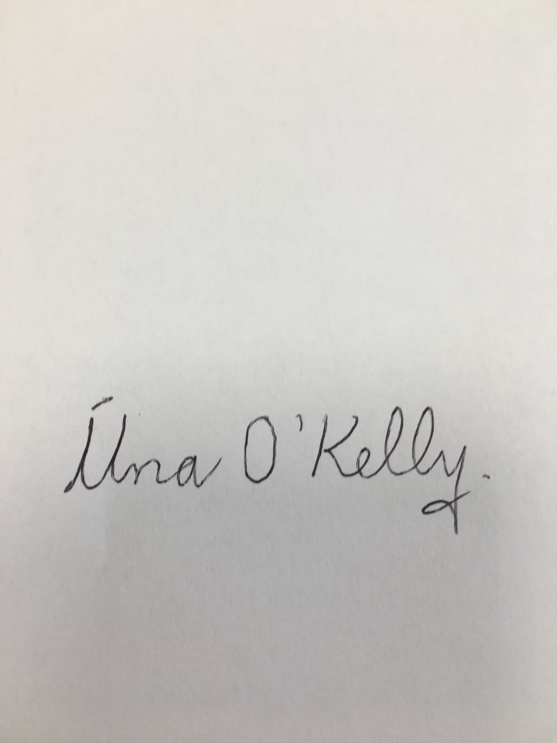
Úna O’Kelly B.ED., M.ED., Post Grad Dip Educ. Leadership, Advanced Dip Law and Education
Principal Teacher

To My Grown Up Child

My hands were very busy during the day,
I didn’t have much time to play,
The little games you asked me to,
I didn’t have much time for you.

I’d wash your clothes, I’d sew and cook,
But when you’d bring me your picture book,
And ask me please to share your fun,
I’d say “a little later son.”

I’d tuck you in all safe at night,
And hear your prayers, turn out the light,
Then tiptoe, softly, to the door,
I wish I’d stayed a minute more.

For life is short and years rush past,
A little boy/girl grows up so fast,
No longer is he at your side,
His precious secrets to confide.

The picture books are put away,
There are no children’s games to play,
No good night kiss, no prayers to hear,
That all belongs to yesteryear.

My hands, once busy, now lie still,
The days are long, and hard to fill,
I wish I might go back and do,
The little things you’d asked me to.

Our School Crest

Our school crest below has been adapted from one designed by a pupil from Saint Joseph’s N.S.

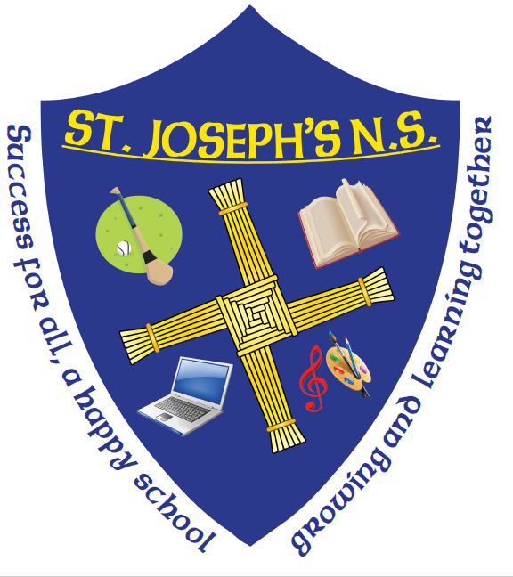

The principal elements of our crest are:

- The Saint Brigid’s Cross is associated with County Kildare.

- The book signifies the academic excellence and nature of our school.

- The Painting accessories signify the creativity, imagination and dedication to the Arts education of St. Joseph’s NS .

- The ball is indicative of the excellence and variety of sport in our school which embrace Football (GAA & Soccer), Hurling, Volleyball, Basketball, Athletics, Cross-Country to mention a few.

- The Musical note is a reminder of a variety of musical related activities in which we part-take such as the Peace Proms Concert, National Children’s mChoir, Carol Services and the importance of such in a child’s life.

- The Laptop reminds us that technology is all around us and we embrace it in our teaching and learning whilst having a strong awareness of using it appropriately with children.

Our School Motto

‘Success for all, a happy school;
learning and growing together’

Special Educational Support Team

Our Support Team provide additional help with language literacy, numeracy and support children with learning difficulties/disabilities. The greater the need the greater the level of support. The Department of Education and Skills allocate support to schools on an annual basis and schools offer that support based on the children’s needs. If your child qualifies for support he/she will receive additional teaching support from Special Education teacher(s) and/or support from a Special Needs Assistants (see note below*).

Support is generally offered within the class but sometimes withdrawal of small groups of children from class may be offered and other times a ‘whole class’ intervention. Each child is given every opportunity to succeed. Consultation with staff and parents/guardians in relation to the children’s progress occurs on request, by either party.

The SEN together with the class teacher set both short-term and long-term educational goals, in consultation with parents/guardians.

* Special Needs Assistants (SNA’s): Special Needs Assistants are employed by the DES to help children integrate into school life. These children traditionally had a diagnosed Disability AND have a physical, medical or care need but now access to an SNA is based on needs. Very often, one SNA will work in a number of classrooms supporting different children with varied needs. Should your child need additional support you should contact the school well in advance of his/her enrolment.

The Primary School Curriculum

The Primary School Curriculum has been recently revised and is taught throughout the school. A New Language Curriculum for Irish, English and Maths has been introduced. All teachers received additional in-service training in many of the curricular areas. The Department of Education and Skills (DES) have compiled a guide on the Revised Curriculum for all parents/guardians and this is available on the DES website.
The curricular areas your child will be studying in school are as follows:
- Languages: English and Irish
- Religious Education
- Mathematics
- Social, Environmental and Scientific Education: History, Geography & Science
- Arts Education: Visual Arts, Music and Drama
- Social Personal and Health Education (see below)
- Physical Education
- SPHE: This programme includes ‘Stay Safe’, Walk Tall and Relationships & Sexuality Education.

St. Joseph’s organises extra-curricular subjects and activities in such a way as to promote particular aspects of a child’s development. This includes the social, academic, mental, aesthetic, emotional and physical development of your son/daughter.

Information & Communication Technology (ICT)

St Joseph’s NS has the very prestigious title of being a ‘Digital School of Excellence’ since 2014 which recognises the importance of all pupils having the opportunity to acquire computer skills to equip them as adults for the rapidly changing world outside and as a tool to enhance the delivery of all subjects of the Primary Curriculum. This is achieved through the embedding of key digital skills using a cross-curricular approach. The ability to use online information sources and tools to explore, investigate, analyse, exchange and present information and to develop problem solving and critical thinking skills is seen as a crucial part of their overall education.

Our school provides a suite of iPads, chromebooks and coding devices which are used by pupils to develop these skills and pupils are also taught the importance of internet safety. In addition, each classroom is equipped with an interactive whiteboard, which allow teachers to deliver stimulating, multisensory lessons.
Extra Curricular Activities

Sport: The school recognises the importance of sport for both social and health reasons. With the help of staff
Each year teams are entered in competitions such as Cross-Country Athletics, Basketball, Soccer (F.A.I 5 a-side), Cumann na mBunscol gaelic football, hurling & camogie, rugby and cricket blitzes. Swimming classes are organised for Third classes each year. This is in line with the ‘Aquatics’ strand of our Revised Curriculum and are a tremendous success. Zumba dance classes are also organised for 4th class.

After School Clubs: We offer soccer, Irish Dancing, drama, music– all very popular with the children and you should contact the coaches/after school teachers directly should you wish your child to participate. We also have many clubs that teachers organise after school such as Homework Club, Dance, Drama, Science, Art, Lego, tin whistle, Choir and many other clubs.

Quizzes: Teams are entered by the school for many quizzes and parents play an important role in bringing the children to the quizzes. This encourages interest in general knowledge and current affairs. In 2023 we came joint 3rd in the All Ireland final of the Credit Union Quiz and in 2024 we came 5th in the regional final.

Educational Tours: Traditionally, school tours visited historical and educational venues. However, nowadays, the school tour tends to focus on the ‘Outdoor & Adventure’ aspect of our PE Curriculum. Teachers will always combine it with an historical/educational dimension whenever the location permits. We try to balance an element of fun, but bear in mind that they are educational trips in line with the revised curriculum.
Other School Activities

St Joseph’s NS is a Green School and pupils are encouraged to keep the school litter free and re-cycle their waste. A Green School Flag acknowledges our efforts. We are an Active School and have been awarded an Active School Flag. Pupils are encouraged to be active and walk and run. Participation in a wide range of games is also promoted.

Senior classes in St Joseph’s NS regularly take part in the Intel Mini Scientist competition and previously we got to the All Ireland Finals and won ‘The Most Innovative Award’! We have also participated in the Junior Entrepreneur Programme, the ESB science Blast and our School Choirs participate in Peace Proms, Cór na nÓg and Córfhéile na scoileanna.

At Christmas time our choirs visit Parke House and Mount Pleasant Lodge Nursing Homes. Library visits to Kilcock Library are organized and the senior children visit the library monthly. We also have a well-stocked school library which is managed by an SNA volunteer and our parent volunteers.
Pupils throughout the school are encouraged to compete in a range of Art Competitions.

School Uniform

The children of St. Joseph’s wear navy and royal blue uniforms. The children wear a royal blue sweatshirt, royal blue polo shirt with navy trousers/skirt/pinafore/loose fitting shorts. All pupils also have a navy tracksuit which they wear on PE days. However, the uniform is completely interchangeable and may be worn in a ‘mix and match’ format every day, unless specifically told otherwise. Both uniform and tracksuits are available from ‘Books and Gifts’ in Kilcock and also from ‘The Uniform Warehouse’ in Maynooth. Any items without the school crest are widely available in other shops also.
We encourage the children to wear the uniform at all times and would appreciate your support in this area. It is important to label all items of uniform and tracksuit (particularly ‘tops’) to avoid confusion. We do not have a Lost Property Box as this tends to get filled and many items are never seen again! Therefore, we collect all items after breaks and check who is missing items daily. At the end of each term all clothing left in the school is washed and donated to Charity Shops.
The School Day

School starts each day at 8.50am and students are expected to arrive punctually. The school day ends at 2.30 p.m. for all classes except the Infants, who finish at 1.30 p.m. There are two breaks each day, 20 minutes at 11.10am and lunchtime begins at 12.40pm.

Children who arrive early can enter the school grounds at 8.40am and will be supervised until 8.50a.m.when respective class teachers assume responsibility for their pupils. No responsibility will be accepted for pupils who arrive on the school grounds prior to 8.40am. Our ‘Duty of Care’ towards your child commences once the gate is opened by the supervising adult and the children are on school property. Up until that point the school bears no responsibility for the safety of your child.

We ask you not to leave your child in the rain in the mornings. We also ask that you to wait with him/her until the school opens when you can be assured that he/she will be properly supervised. Children will be dismissed by their class teacher at 2.30pm (1.30pm Infants) daily and no further responsibility lies with the school thereafter unless specific arrangements have been made between you and your child’s teacher.

Due to the traffic congestion at each end of the school day we urge parents/guardians to ensure that their children understand the Rules of the Road. Also, please do not allow your child to walk through the Car Park but encourage him/her to always use the footpaths and to cross at the pedestrian crossings On icy mornings the Car Park may be closed to ensure the Health & Safety of your child.
Homework

Homework is very important as it consolidates work done in school. Parents/guardians are advised to provide a regular time and a suitable place for doing homework. Children should be encouraged to take fresh air and exercise and should only spend the recommended amount of time on any particular night’s homework as directed by their class teacher. We recommend 5 minutes from Junior Infants onwards with an increase of 5 minutes each year, so 15 minutes for First, 20 for Second class and up to 40 minutes for Sixth Class. Children do not have Homework on Fridays.

Child Protection

St. Joseph’s NS adopts all the Tusla Procedures in relation to Child Protection as directed by the DES under the revised Child Protection Procedures of 1st September 2023. All teachers are now mandated to report to Tusla concerns they have in relation to child welfare and/or Child Protection. We will follow these Procedures when a disclosure is made as we have a duty to protect every child. Every parent will receive a copy of our Child Protection Policy and Risk Assessment.

Ms O’Kelly (Principal) is the ‘Designated Liaison Person’ (DLP) and Ms McNickle (Deputy Principal) is the Deputy Liaison Person. You should notify Ms O’Kelly in the event of a disclosure in relation to Child Protection matters or to Ms McNickle if she is not in attendance at that time.

Each teacher teaches Social, Personal and Health Education (SPHE) each week and these lessons are based on three particular programmes –Walk Tall, Relationships and Sexuality Education and the Stay Safe Programme. They are taught for a term each throughout the academic year. Worksheets are an intrinsic part of these programmes and should be signed by parents whenever applicable. They provide you with a guide as to content covered in class and an opportunity for you to further discussion around sensitive issues.

Parental Involvement

Teachers appreciate all the help given by parents with school related activities such as football matches, Sports Days and other extra-curricular activities, subject to the necessary vetting requirements under Child Protection legislation. Parents/guardians are always welcome in the school and we encourage you to come on a regular basis to visit us. Children of all beliefs attend St. Joseph’s N.S. and are very welcome. Parents of children receiving the Sacraments are invited to help the teachers prepare their children.

However, with Child Protection Procedures we must now ask you to present directly to the School Office. You should not to go through the school building unaccompanied by a staff member. If you are collecting your child early we will collect him/her for you.

Pupil Absence or early departure
Notes/letters from parents are requested by the National Education Welfare Office (NEWB) and by law following any absence of a pupil from school. The easiest way to do this is through the Aladdin connect school app. After 20 absences we are obliged to report the absences to the Education Welfare Officer. In the event of a parent wishing his/her child to leave school before the normal time of dismissal you are requested to inform the school Office. All parents must complete the sign in/sign out sheet at the secretary’s office if dropping a pupil in late or collecting a pupil early. Please also email or send in a note if you wish your child to remain indoors for breaktimes.

Parent Teacher Meetings
If you have any concerns about your child contact your child’s teacher(s) immediately. We cannot help if we are not aware of a problem or concern. Formal Parent/Teacher meetings take place during the year, usually in November and it is very important that you attend. Written reports are sent home in the middle of June so that you have time to come in and talk to individual teachers if you wish.

Our Parents’ Council
The Parents’ Council is a very important part of our school community and we have a particularly active, enthusiastic and friendly group of parents who are the ‘life blood’ of our school – they are with us all the time supporting everything we do. They usually meet each month to support us in our work with their children. Their primary focus is as follows:
- To foster co-operation between parents/guardians, teachers and school management.
- To inform parents/guardians of developments in education and in the school.
- To represent the views of the parents/guardians.
- To raise funds for much needed equipment for the school.
- To help out with school activities such as concerts, book fairs, library time, etc.
They have an excellent Facebook page and their current Chairperson is Dave Weldon. They elect their members in October of each year at the Annual General Meeting. It is important that you attend such meetings and support your child’s school. Research would suggest that your involvement in your child’s schooling helps your child achieve better in school. Their email address is stjosephsnspc@gmail.com.
Board of Management

The key responsibility of the Board of Management involves the direct governance of the school. They plan for the future of the school and oversee the work of the Principal and school staff. They are responsible for the appointment of all staff subject to the Patron’s and Minister’s approval. They endeavour to ensure that a quality service is available to the children and their families. They formulate school policy and are responsible for all school accounts.

The current B.O.M was elected in December 2024 and will hold office for 4 years. Eight people make up the membership of the BOM from which the Chairperson is elected. Our Chairperson is David Powderly. The Parents’ Representatives must have one mother and one father. The members of the BOM are as follow:
Patron’s/Bishop’s nominees: David Powderly & Fr George Augustine
Staff nominees: Úna O’Kelly(Principal) & Niall Higgins (teacher nominee)
Parents’ Nominees: Ian McGill and Gemma Maguire
Community nominees: Lorraine Woodward & Elaine Ryan

History of St. Joseph’s NS, Kilcock

The history of the St. Joseph’s NS begins when the Christian Brothers arrived in Kilcock in the 1871 when a school was built in School Street with stone left over from the construction of the local church tower. This school was to serve the educational needs of the local boys for one hundred years, by which time the many reasons for a new school building were only too obvious. In 1973, Bro. Farrell came to Kilcock and was expected by his superiors to build a new school with the permission of Fr. O’Meara P.P. However, at that time funds were not available and so the old school, now one hundred years old, was repaired by voluntary workers.

However, the boys of the parish needed a better building than the one in School Street. No one knew this better than Fr. McWey who came to Kilcock in 1976. After lengthy negotiations with the Department of Education and the Board of Works, permission for a new school building was granted. A four-acre site was purchased in Highfield by the Parish for £12,600. Work began on the site in August 1978 and completed in the Spring of 1980 at a total cost of £237,000.

St. Joseph had been the patron saint of the old school and so March 19th 1980, the Feast of St. Joseph was chosen as the date for the opening of the new school. A special Mass was celebrated in the new school hall, attended by the teachers, parents and pupils. Gone forever were the cold, smoke-filled, high ‘ceilinged’ and noisy classrooms. In their place were warm, bright, well furnished, carpeted rooms. Tables and chairs took the place of the old heavy desks. Indoor toilets replaced the outdoor facilities. The P.E. hall was an added bonus especially during wet and cold weather.

Four teachers, Bro. Doherty, Mrs. Tuite, Mr. Brennan and Miss Finnerty along with 114 pupils moved in on that day. That spacious yard and playing field will forever stand as a memorial to the far-sightedness of Fr. McWey. September 1980 brought further changes. Our Infant boys who had previously been schooled in St. Coca’s Convent School now came to St. Joseph’s CBS. Our first ever class of Junior Infants was enrolled in St. Joseph’s NS in 1980. This required additional teachers with Sr. Philipa and Mrs. Tierney coming from the convent and Mr. Costello from Dublin.

In 1986, as a result of the decline in the number of vocations in the Christian Brothers, a decision was made that they should leave Kilcock. This was the end of an era for everyone in Kilcock. The late Fr. McWey became the Chairperson of the B.O.M. The school was now a Boys National School with its first lay Principal, Mrs. Kathy Tuite. Mrs. Tuite served this school for a continuous period from 1972 to 2000.

Ms. Ann McQuillan became the principal teacher in 2000. In 2015, we opened our doors to girls and became a co-educational school. In 2021, we moved to our third school building at the back of our field.
In 2023 Ms O’Kelly became our new principal teacher.

As we continue on our journey in the new millennium, we look back with pride at the many achievements of our school. St. Joseph’s has provided the scope for children to develop their individual talents. Academically, St. Joseph’s, has given a good foundation to the many, many girls and boys who later went on to have great success in the sporting, professional and business worlds and continues to do so now for girls and boys. The entire community of St. Joseph’s NS hope that our present and future pupils will be just as happy and successful as their predecessors.

Reflection

If I had a child to raise all over again,
If I had a child to raise all over again,
I’d build self-esteem first and the house later.
I’d finger-paint more and point the finger less.
I would do less correcting and more connecting.
I’d take my eyes off my watch, and watch with my eyes.
I would care to know less and know to care more.
I’d take more hikes and fly more kites.
I’d stop playing serious and seriously play.
I would run through more fields and gaze at more stars.
I’d do more hugging and less tugging.
I’d see the oak tree in the acorn more often.
I would be firm less often and affirm much more.
I’d model less about the love of power,
And more about the power of love.

Diane Loomans.

